Daily Remit Coin (DRC)
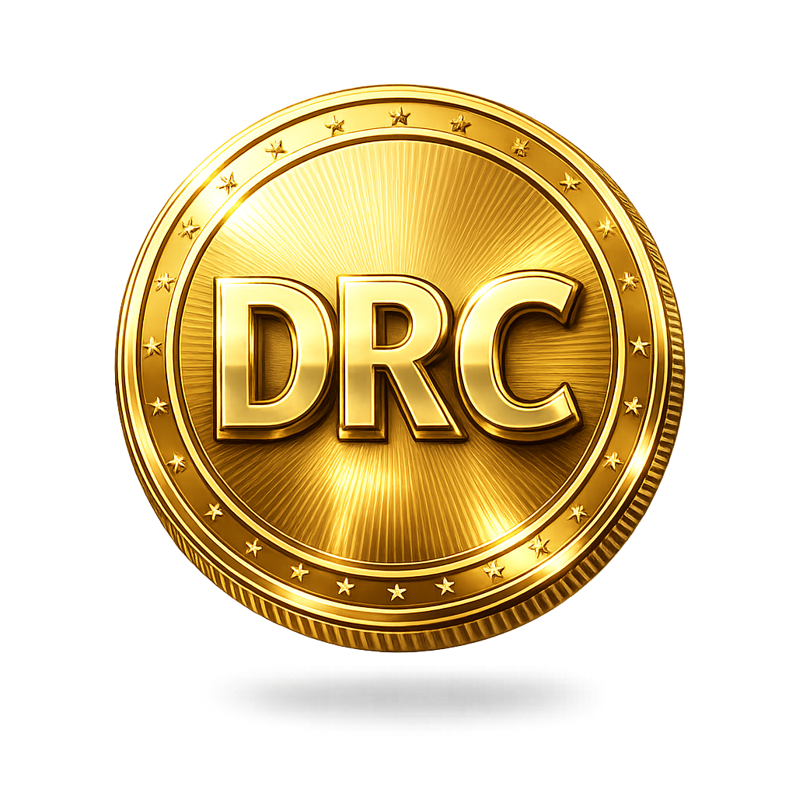

WHITEPAPER V1
Future-Proof Multi-Use Cryptocurrency

Introduction
Daily Remit Coin (DRC) is a next-generation digital asset built to power fast, low-cost, and secure global transactions. By leveraging blockchain technology, DRC eliminates the inefficiencies of traditional remittance systems while expanding into a scalable ecosystem of DeFi, NFTs, staking, and decentralized governance. Designed for both real-world utility and long-term growth, DRC aims to become a cornerstone of borderless finance.

Problem & Solution
Traditional remittance systems are expensive and slow. DRC solves this with decentralized, near-instant transactions and global accessibility.

Market Inefficiencies & the DRC Advantage
Global remittance infrastructure remains outdated, characterized by excessive fees, multi-day settlement periods, and restricted access for millions of unbanked individuals. These limitations hinder financial inclusion and reduce the efficiency of cross-border economic activity.
DRC introduces a decentralized alternative, enabling frictionless, near-instant global transactions with significantly reduced costs. Built on blockchain technology, the protocol ensures transparency, security, and scalability while eliminating reliance on centralized intermediaries.
As part of a broader ecosystem, DRC extends beyond payments into DeFi, staking, NFTs, and governance, positioning itself as a comprehensive solution for the future of borderless finance.

🔥 Why this is better
- Sounds like real investor documents
- Uses industry language (intermediaries, infrastructure, inclusion)
- Expands beyond just “remittance” → shows big vision Tokenomics & Economic Model

Tokenomics & Economic Model
Total Supply: 1,000,000,000 DRC
Decimals: 18
Network: BNB Smart Chain (current)
Transaction Fee Structure
- 1% Marketing
- 1% Development
- 1% Liquidity
- 1% Burn – (permanent delete from Total supply)

Key Features & Competitive Advantages
🔥 Deflationary Burn Mechanism
DRC will implement a continuous burn mechanism to reduce total supply over time, supporting long-term value appreciation.
💰 Staking Rewards
Holders will be able to stake DRC to earn passive income, encouraging long-term participation and network stability.
📉 Supply Reduction Model
Automated burn functions will gradually decrease circulating supply, enhancing scarcity and value dynamics.
⚖️ Balanced Ecosystem Growth
A structured fee model will ensure sustainable funding for development, marketing, and liquidity.

Transaction Fee Structure
Each transaction within the DRC ecosystem applies a 4% total fee, designed to support sustainability, growth, and long-term value:
- 1% Marketing — Drives adoption, partnerships, and global awareness
- 1% Development — Funds continuous platform upgrades and innovation
- 1% Liquidity — Strengthens market stability and trading depth
- 1% Burn Mechanism — Permanently reduces supply to create deflationary pressure

Technical Architecture
DRC is built on BNB Smart Chain with secure smart contracts, staking mechanisms, burn system, and DAO governance readiness.

Ecosystem & Use Cases
Daily Remit Coin (DRC) is designed as a multi-utility digital asset that will support a wide range of applications across the blockchain ecosystem. Its architecture is intended to enable real-world adoption while expanding into multiple decentralized sectors.

💸 Payments & Remittance
DRC will enable fast, low-cost, and secure global transactions, making it suitable for cross-border payments and remittance solutions. Users will be able to transfer funds instantly with reduced fees compared to traditional financial systems.

🖼️ NFT Ecosystem
DRC will support NFT creation, trading, and marketplace integration, enabling digital ownership, collectibles, and tokenized assets across various industries.

📊 Decentralized Finance (DeFi)
DRC will integrate with DeFi protocols, allowing users to participate in staking, liquidity provision, yield farming, and decentralized lending/borrowing.

👛 Wallet Integration
DRC will be compatible with major crypto wallets and will support the development of a dedicated DRC wallet for secure storage, transfers, and seamless interaction with the ecosystem.

🏛️ DAO Governance
DRC will introduce decentralized governance, enabling token holders to vote on proposals, protocol upgrades, and ecosystem decisions.

🔗 Cross-Chain Compatibility
DRC will be developed for interoperability, allowing integration across multiple blockchain networks to enhance scalability and user accessibility.

🎮 Play-to-Earn (P2E) Gaming
DRC will support integration with blockchain-based games, enabling users to earn rewards through gameplay and participate in digital economies.

💳 Merchant Payments & E-Commerce
DRC will be integrated into payment gateways, allowing merchants to accept DRC for goods and services globally.

🏦 Staking & Passive Income
DRC holders will be able to stake their tokens to earn rewards, encouraging long-term holding and ecosystem participation.

🌍 Financial Inclusion
DRC will provide access to financial services for unbanked and underbanked populations, enabling participation in the global economy.

📱 Mobile Application Ecosystem
A dedicated mobile app will allow users to manage assets, send payments, stake tokens, and interact with DRC services in one platform.

🔐 Smart Contract Utilities
DRC will support integration with decentralized applications (dApps), enabling automation, secure transactions, and programmable financial services.

🧩 Developer Ecosystem
DRC will encourage developers to build on its ecosystem through tools, APIs, and future blockchain infrastructure.
Roadmap & Strategic Development (2026–2035)

📍 Phase 1: Foundation (2026)
- Launch of Daily Remit Coin (DRC) on BNB Smart Chain
- Official website and brand identity release
- Initial liquidity provisioning
- Community building (Telegram, Discord, Twitter)
- Listing on decentralized exchanges (DEXs)
- Smart contract deployment and security validation

📍 Phase 2: Growth & Utility (2027)
- Launch of DRC staking platform
- Introduction of NFT ecosystem and marketplace
- Strategic partnerships and collaborations
- Expansion of marketing campaigns and global outreach
- Initial centralized exchange (CEX) listing efforts

📍 Phase 3: Expansion (2028–2029)
- Development of DRC native wallet (mobile & web)
- Integration with DeFi protocols (lending, yield farming)
- Cross-chain compatibility (multi-network support)
- Play-to-Earn (P2E) gaming integrations
- Ecosystem scaling and user adoption growth

📍 Phase 4: Ecosystem Maturity (2030–2032)
- Launch of DAO governance (community voting system)
- Release of fully functional mobile applications
- Expansion into enterprise and payment solutions
- Advanced DeFi tools and financial services
- Strengthening global remittance infrastructure

📍 Phase 5: Future Vision (2033–2035)
- Development of proprietary DRC blockchain
- Full ecosystem independence and scalability
- Global remittance adoption and real-world integration
- Institutional partnerships and financial integrations
- Continuous innovation and ecosystem expansion

Future Blockchain Strategy
Daily Remit Coin (DRC) will initially be deployed on an established blockchain network to ensure rapid deployment, security, and accessibility. As for now it will is deployed in BNB chain. This approach enables immediate integration with existing infrastructure, including wallets, exchanges, and DeFi platforms.
As the ecosystem grows, DRC is designed to transition into its own native blockchain, enabling greater scalability, independence, and full control over network functionality. This evolution will support advanced features such as custom governance, enhanced performance, and a dedicated validator ecosystem.

Adoption & Expansion Strategy
DRC’s growth strategy is focused on building a strong global community, expanding market presence, and driving real-world adoption through a combination of strategic marketing, partnerships, and ecosystem development.

🌍 Community Growth
- Establish and grow active communities across Meta, X formerly (Twitter), Telegram, Discord, and other social platforms.
- Incentivize participation through rewards, campaigns, and Airdrop events
- Transparent and engaged user base

📈 Exchange Listings
- Initial listings on decentralized exchanges (DEXs)
- Gradual expansion to centralized exchanges (CEXs)
- Increase liquidity and accessibility for global users

🤝 Partnerships & Collaborations
- Strategic partnerships with blockchain projects and platforms
- Integration with wallets, DeFi protocols, and payment systems
- Collaboration with fintech and remittance-focused services

📣 Marketing Campaigns
- Influencer and KOL (Key Opinion Leader) partnerships
- Social media campaigns and targeted digital marketing
- Global awareness campaigns focused on remittance use cases

🚀 Ecosystem Expansion
- Promotion of DRC utility across DeFi, NFTs, and staking
- Incentivized adoption through rewards and ecosystem benefits
- Continuous onboarding of users and developers

Conclusion & Future Outlook
Daily Remit Coin (DRC) is positioned to become a scalable and future-proof digital asset, designed to address real-world financial challenges while enabling a broader blockchain ecosystem. By focusing on fast, low-cost global transactions, DRC delivers a practical solution to the inefficiencies of traditional remittance systems. Beyond its initial use case, DRC is structured to evolve into a multi-utility ecosystem spanning decentralized finance (DeFi), NFTs, staking, and governance. Supported by a clear long-term roadmap and sustainable Tokenomics, the project is built to adapt and grow alongside the rapidly changing digital economy. With a phased strategy that includes transitioning from a token to a native blockchain, DRC aims to establish itself as a foundational layer for borderless finance. Through innovation, community engagement, and real-world adoption, DRC seeks to create long-term value for users, developers, and investors alike.
“DRC is not just a digital asset — it is a step toward the future of global, decentralized finance.”

